CWRC

Lectora Style Guide and ADA Updates
Contents
All about COLOR! 3
Ampersand 5
Animations 5
Audio/Video 5
Bulleted Lists 6
Buttons, Hyperlinks, Images Used as Links & User Actions 6
Buttons – Requiring 7
Buttons – Requiring Multiple 9
Button States 10
Charts 10
Checkboxes 11
Checking Files in and Out of Lectora Online 11
Conveying Meaning through Non-Text 12
Drag and Drop 12
Dropdown Menus 13
Font 13
Forms 13
Headers, Sub-Headings, Special Notes etc. 13
Hover 13
Images 14
Tagging Images Basics 14
Decorative Images or Elements 14
Master slide items 15
Creating Accessible Text Descriptions 15
Accessible Text Description for a Popup Text Box 15
Retroactively create new pages in the POPUP chapter 15
Assistive Text Equivalents: Replacing a Complex Image, Infographic, or Chart 18
Keyboard Interface/QA Notes 21
Language 22
Message Popups 22
No Surprises! Rule 22
PDFs 23
Popup Chapter 23
Progress Bar 24
Read Order for Screen Readers and Tagging 24
Changing read order 24
Responsive Design 25
Scrolling 25
Sectioning and Assessments 25
Slide Layout 26
SuperNext 26
Table of Contents 26
Tests 27
Text Boxes 27
Timing 28
Title Tagging 28
Transitions 30

Note: some screen shots were taken before line spacing and font were adjusted- be assured that 1.5 line spacing, with 12 points after each paragraph is the rule despite the images. In time, these will be updated.

All about COLOR!
- Ensure color contrasts are compliant using an online checker https://contrast-finder.tanaguru.com/result.html?foreground=%23000000&background=%23ffb81c&ratio=4.5&isBackgroundTested=false&algo=Rgb
  - Contrast ratio of at least 4:5 (except for large text which requires 3:1, incidentals, or logotypes)
  - Example: Enter codes for black (0,0,0) and gold (255,184,28). Select Minimum Ratio of 4.5 and then Check and find contrast:
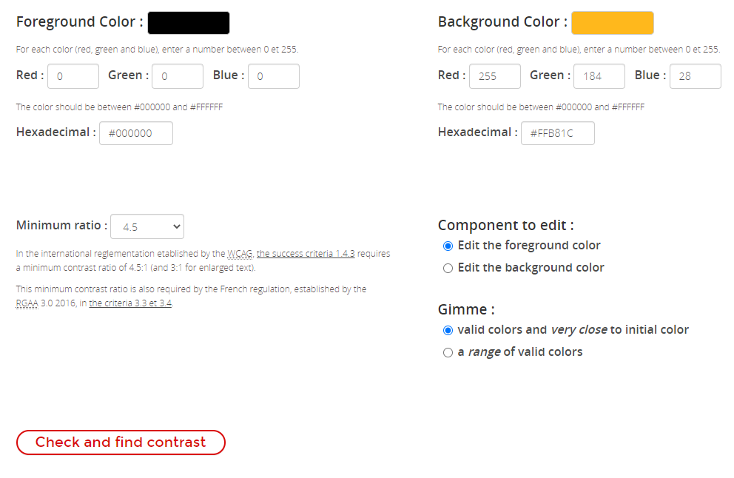

Scroll down for the following results:
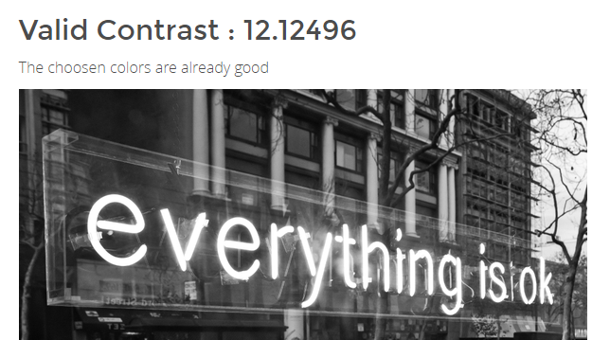
If your example is not good such as with the following:
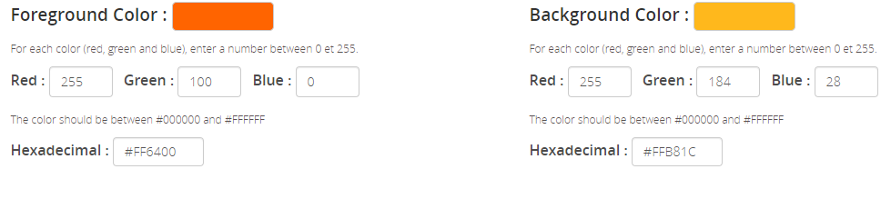
You will get the following results, which indicate a contrast ratio of only 1.7138, which is not compliant:
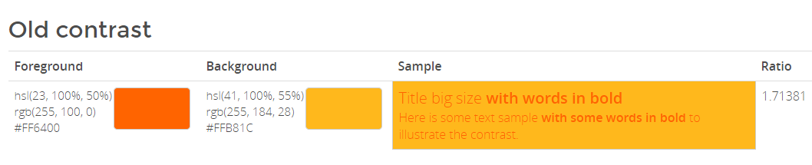
- Go to our Pitt color cheat sheet for which Pitt colors are to be used with white or black fonts; I’ve done the work for you: https://pitt.sharepoint.com/:w:/s/CurriculumTrainerDevelopment/ERLpN6ptWkNFml1jK2OBlZMBRdgPtcso4VFPN4R76J4PdA?e=XcRFw6&CID=14531EDC-EFAB-49DE-9256-E7AC55DDD760&wdLOR=c2B2E9324-3F91-412F-9C0E-1AF01B178E03
- Research shows that for many with autism, yellow is disturbing – use with care
- Avoid using red for bad; green for good (red and green are most common issues for color blindness)
- Avoid using color for meaning if possible
  - We’ll cover how to keep colors with meaning AND make access equitable in a future update! In the meantime, if you are using color to indicate meaning, please contact Jenny for a workaround.

Ampersand
Try to avoid using the ampersand symbol (&) unless it is used in a source – it’s easier for learners using screen readers to hear and then to have the symbol.

Animations
Do not use on screen animations such as moving or flying in, fades, or flashing.

Audio/Video
- Audio and video must not automatically play (the learner must activate the play function), and the user must be able to pause, stop, and adjust volume on the audio or video recording. (The auto play function interrupts a screen reader.)
- Audio and video must have synchronous captioning
- If actions occur in a video that are important, the actions must be described in the captioning and convey equitable meaning
- If there are sounds in audio that add to the meaning of the words in the transcript, the sounds must be described in the transcript to provide equity
- For audio, ensure that foreground speech is clear with no background noises

Bulleted Lists
- 1.5 line spacing
- Indented one setting from main text (not entered in a separate text box)
- Not complete sentences or end in periods if possible
- Between intro sentence and bullets and among bullets, 1.5 line spacing NO extra spacing after paragraphs/DO NOT USE HARD RETURNS TO ADD BLANK SPACES BETWEEN PARAGRAPHS
- After bullet list before next paragraph, 12 pt
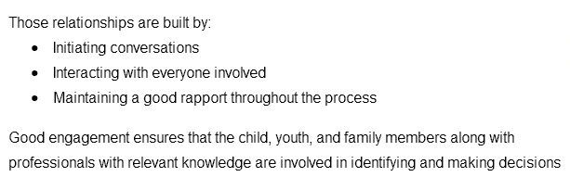

Buttons, Hyperlinks, Images Used as Links & User Actions
- Whenever asking the participant to do something (select a link, button, image, save, print etc., clearly state the directions on the slide, do not reference direction such as below, do not use click, and use a colon as in the following example:
  - Please select the button for more information about the Family Service Plan:
- Anything acting as a button or hyperlink needs to be labeled in Title Explorer as what they are and include what they will do
  - For example: Button to PA Child Welfare Practice Model web page
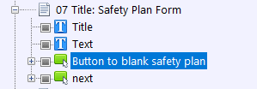
(The bottom next button is the one with conditional formatting that requires the safety plan button be used to proceed; you do not need to further define the button. On old courses, please rename the bluestampback and bluestampnext buttons to simply back or next).
- Balance brevity with clarity
- By providing direction you are helping to meet the No Surprises! Rule (reference section by that title)
- Within each module (or even series) use consistent button styles (while ensuring that color contrast and font size meet ADA criteria)
- Only use a few buttons per slide – for more information, consider creating a job aid that can be saved or printed (a win-win situation, less clicking and repetition and more job aids!)

Buttons – Requiring
Generally, when we use buttons for the first time, we require users to select it.
- Copy a Next button and past it on the page on which you are requiring an action.
- Page properties, Inherit Settings, Exclude inheritance of certain objects – select the Next button on the Inherited list and hit the triple arrow to it moves to the Excluded list. Select Ok.
- Select the button you wish to require
  - Action tab: 1 of 2 should list the go to action (such as to website, popup etc.)
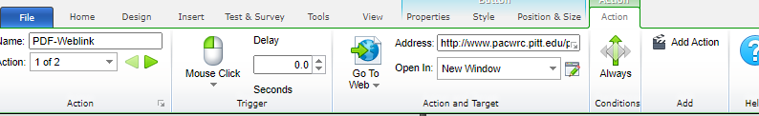
  - 2 of 2: On Mouse Click, Modify Variable, Target: 10Competencies Clicked (rename descriptively); Type Set Equal To: Value 1; Always.
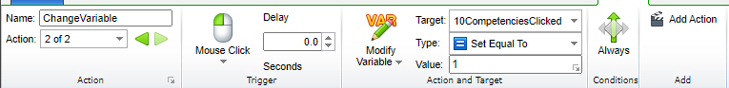
- Select the pasted next button
  - Action Tab, On Mouse Click, Go To, Next Page, IF, All Conditions Must be True, Variable (entered), Relationship Equal to, Value 1. Select OK.
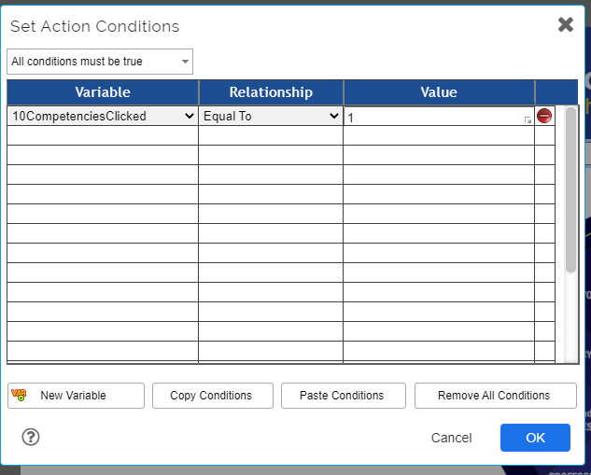
Set Display Message to: “Select the button before proceeding.”
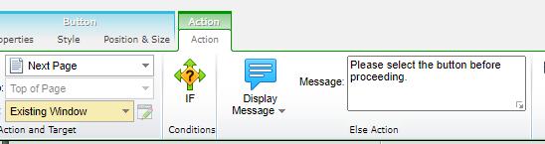

Buttons – Requiring Multiple
Repeat step for Button – Requiring for each button. The Action IF tab for the next button should be set to “All conditions must be true” and list a variable, relationship, and value for each required action:
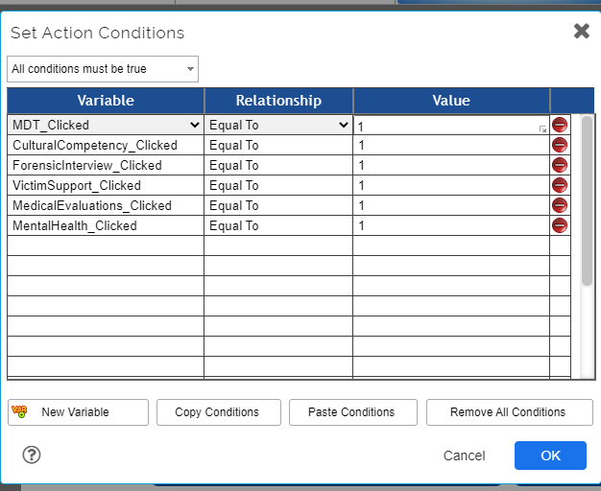
Set Display Message to: “Please select all 6 buttons before proceeding.” (adjusting accordingly)
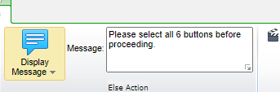

Button States
If you wish to indicate that a button has already been activated, use a high contrast (see color section) or an icon. Do not use low contrast or hover states.

Charts
Do not copy charts created in other programs into Lectora, as that is inserting text as an image, which is to be avoided whenever possible. Instead, build the chart in Lectora using the Tables function. Screen readers will be able to access and relay the text in the chart. Here is a sample Lectora chart with some learning points included:
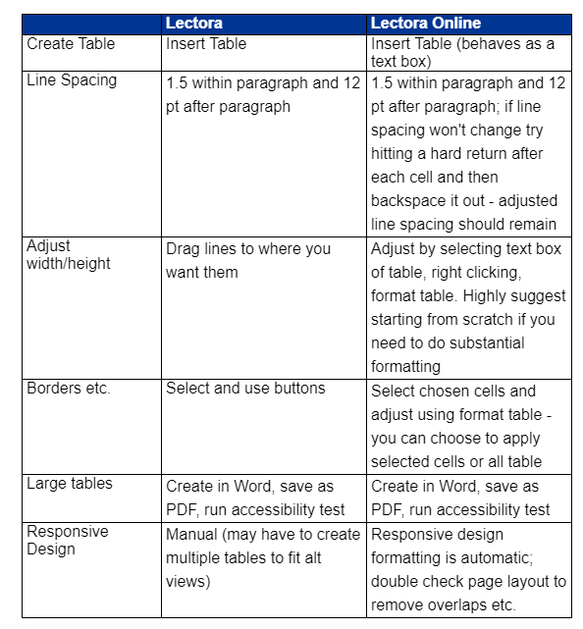

Checkboxes
For multiple choice questions or similar items use the ZESTY checkbox/button design; this ensures that the target for pointing or selection is accessible

Checking Files in and Out of Lectora Online
When using Lectora online you must check files, chapters, or objects before editing them so that multiple users don’t create conflicts. Once you open a file, at the top of the Title Explorer select the Title of the course so it is blue and then select the Green left arrow. If you have not selected the title (or chapter or object) you won’t have the option to check out or in any object. You must select something.
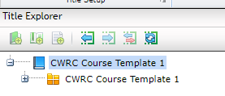
To check the title, chapter, or object back in, select the item and then the right green arrow.
If multiple users are working in a file you can hit the right button which is solid green with a white reloop arrow to update checkin/out status.

Conveying Meaning through Non-Text
Do not use only non-text elements to convey meaning (reference All About Color! for more information)
- Single sensory characteristics such as shape, color, size, locations, orientation, or sound are to be avoided
- Instead, use multiple sensory characteristics to convey information such as color AND an icon, a blue-underlined hyperlink in addition to ensuring that any information conveyed only through visuals are also equitably described in the accessibility alternative.
  - For example, a flowchart often uses shapes, color, font, and directional arrows to convey process or decision-making information. None of those approaches are ADA compliant but can be useful to many participants. Instead of removing or not using a flowchart or infographic, you need to provide an alternative such as a text description of the decision-making process and steps. (Refer to Creating Accessible Text Descriptions under Images for more information.)

Drag and Drop
Do not use drag and drop features; you can redesign multiple choice questions to have a similar effect. Drag and drop designs are not ADA compliant as they require manipulation.

Dropdown Menus
Do not use drop down menus (except for our template Table of Contents). Dropdown menus are not ADA compliant as they require manipulation.

Font and Line Spacing
- Slide Title Font remains at Arial, Bold, 28 pt, Blue
- Body Font (must be a minimum of) Arial, 12 pt, 1.5 line spacing, with 12 points after each paragraph
- Citations are Arial, 12, black font

Forms
- If you are including a form for reference (not completion) or as a pre-completed scenario example, include a link to the form as a OCRs PDF NOT as an image or printed PDF
- If you are including only a portion of the form either recreate it as a table in Lectora or link to it in readable PDF form
- If you are including a form that must be completed by the participant, work with the Tech Department

Headers, Sub-Headings, Special Notes etc.
Headers, and sub-headings, special notes, warnings, and images used as sub-headings (such as PA Child Welfare Competency graphics) must all be tagged with the level in Title Explorer (screen readers won’t recognize that you have bolded something to give it sub-header status so you convey that information with the Title Explorer; you need to indicate the relationships of the text and objects to each other in an additional means than just the visual)

Hover
Do not use hover features to trigger additional content, motion, or anything else

Images
Ensure pictures have the same feel throughout a module or series; generally, avoid cartoons except for well-designed avatars

Tagging Images Basics
- Check default alt tags for images - not all default tags for images are actually descriptive
  - Example: The default image tags are often named by the source or numbers; rename them to indicate content
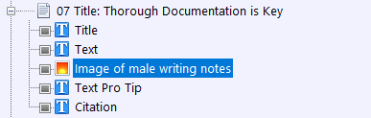
- Another thought about images: "If you can’t write good descriptive text then you probably don’t need that image. If you don’t know how to describe it, then you don’t need it." (Bozarth 2019)
- Descriptive text does not need to be detailed; convey what is adding meaning. (For example, you don’t need to say that Shreya is wearing a teal shirt; however, if Shreya were wearing a t-shirt with a slogan that adds to the meaning, you would include that information.)
- If an image conveys meaning create an alt-tag; please do not use empty alt-tags for items with meaning
Decorative Images or Elements
Note, if you have an image or element (such as a line) that is purely decorative and does not add meaning, consider if you really need the object.
- If you do not need the object, delete it.
- If you do need the object because it adds a decorative element but not meaning, then change the properties to “empty ALT tag”. Doing so instructs the screen reader to skip over mentioning the decorative object.
- Do one of the following to display the Properties ribbon:
  - In the Title Explorer, double-click the graphic of the object.
  - In the Title Explorer, right-click the graphic and select Properties.
  - In the work area, double-click the object.
  - In the work area, right-click the object and select Properties.
- In the Web Options group, enable the Empty ALT Tag check box.
- Images should be placed in the order in the Title Explorer so that the reader will address the image in the context that makes the most sense.
- If your image adds meaning and you can describe what it is or means in 128 characters or less, rename the image as “Image of…” and provide the meaningful details
Master slide items such as the University of Pittsburgh title and shield and footer information. Our template is being adjusted so screen readers will not repeat this information.

Creating Accessible Text Descriptions
Screen readers read only items that are on screen when it originally loads; meaning items checked in Lectora as Initially Hidden will NOT be read. Screen readers also cannot read images showing charts or text. That means we need to create alternative access to keep the screen-read course equitable. There are two options.
- The first is to redesign the slide so nothing is initially hidden, there are no complex images, and there is no text in images. You may not wish to sacrifice engagement and design considerations.
- The second option is to add a text box to explain the content in a way that the screen reader can access, but that is invisible to non-screen reader users. Proceed for two examples applying the second approach.

Accessible Text Description for a Popup Text Box
If possible, create and design your slides so that there are no initially hidden objects.
Retroactively create new pages in the POPUP chapter
- Set your button, image, or hyperlink settings to: New Window, select the window icon then Popup Window, New Browser Window, and ensure that the lower four HTML Only Preferences are checked: No Menubar, No Status Bar, No Toolbar, and No Location Bar.
- You can deselect Inherit Page Size on the popup page and resize the page to better fit your new popup
- If you are copying a pre-existing text box that was initially hidden to a POPUP slide, be sure to uncheck Initially Hidden or your popup slide will remain blank.
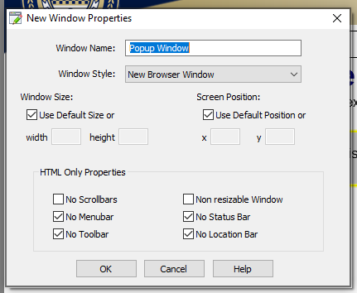
If for some reason the above approach does not work and you need to use an initially hidden object, identify or create your slide as desired with the object check marked as Initially Hidden. In the following example, the shaded documentation popup is selected and marked as Initially Hidden in the menu bar. This popup is designed to appear when the participant selects the documenting hyperlink in the text box 2 paragraph.
- This popup contains important information that must be available to users who want more information on documentation, so we need to ensure it is available for those using screen readers.

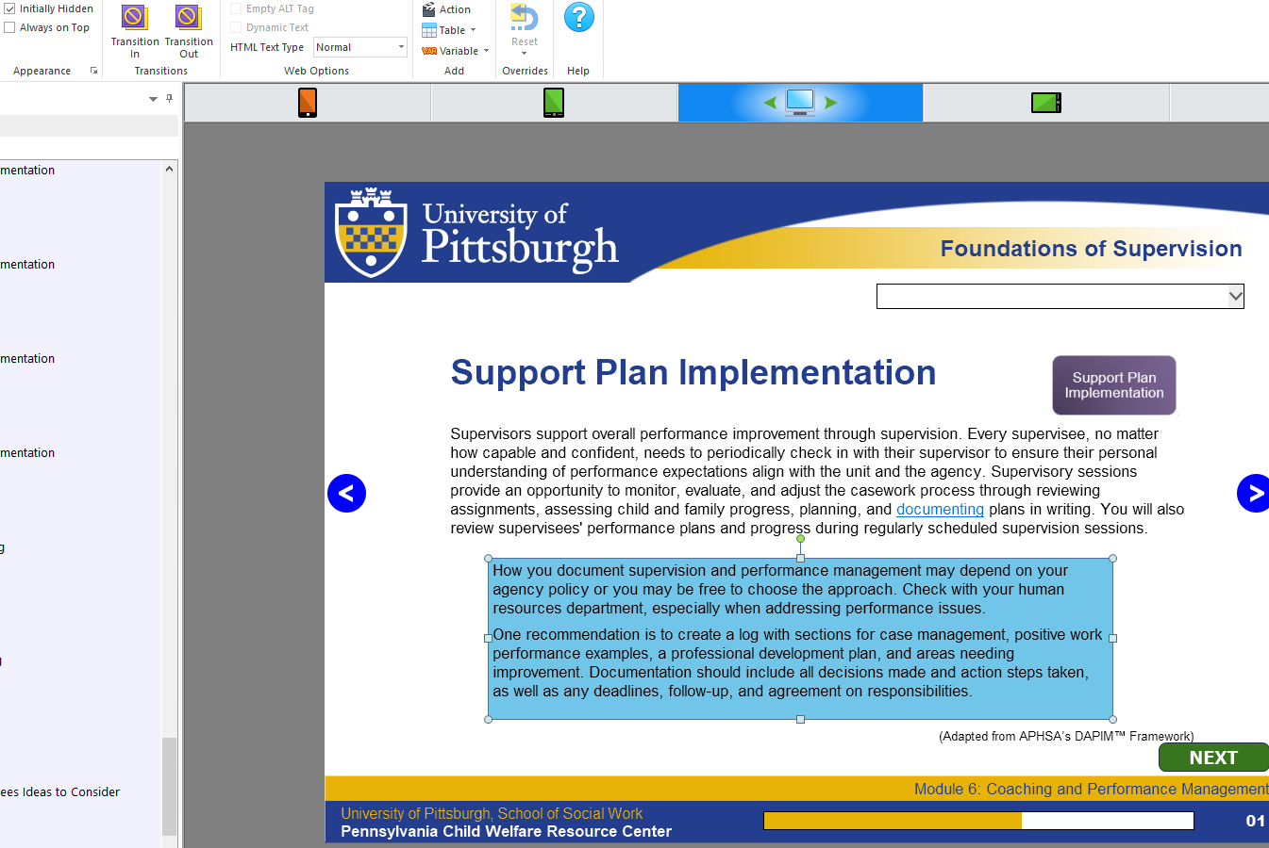
- Select your initially hidden object, which in this case is the documentation popup. Then Copy (CTRL+C) and Paste (Ctrl+V) the object onto the slide. Do not worry about placement or layering at this time.
- In the Title Explorer, be sure to rename your pasted copy as “Assistive text popup”. The name should match the original except for beginning with “Assistive”.
- Select the new Invisible object and adjust the content wording if needed for a screen reader
- Remove the background color (if applicable).
- Change your text box or object size so that it’s smaller than the original object.
- Change the font to white or to match your slide background.
- Reselect the Invisible object and drag the title it so it is ABOVE the original object. Remember, screen readers in Lectora read from top to bottom in Title Explorer. You want the screen reader to read the invisible object BEFORE it names the object it won’t be able to read.
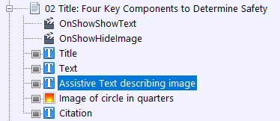

Assistive Text Equivalents: Replacing a Complex Image, Infographic, or Chart
Note: for the following to work, settings must be added to the master slide; tech will do this for the retroactive slides and to future templates (or you can try copying the accessibility functions from an updated course such a Foundations Module 4, Section 6 as shown here; note, all sections need to contain the accessibility additions:
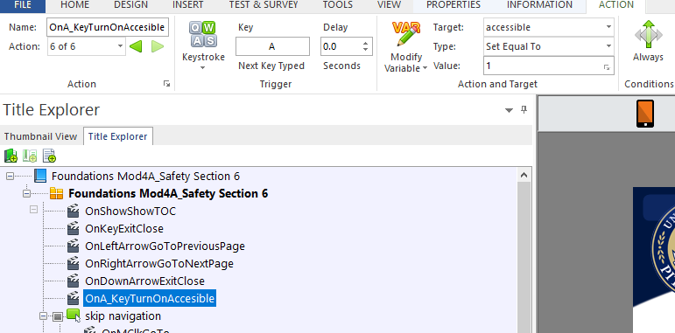
Sometimes you will have a complex image, infographic, chart, or other object that cannot be explained in 128 characters or less, but you still need to equitably relay the meaning. In these cases, the user of assistive technology does not need the original item at all. Rather, they need the text equivalent.
For example:
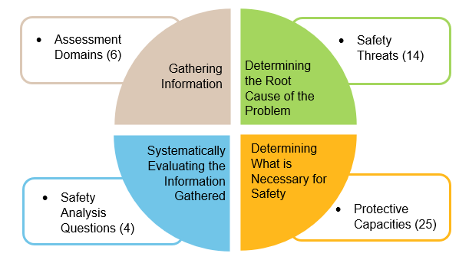
All of the relevant information would take more than 128 characters to relay, so we cannot just rename the tag in the TE.
Instead, create a text box with the text alternative and name it “Assistive text…”

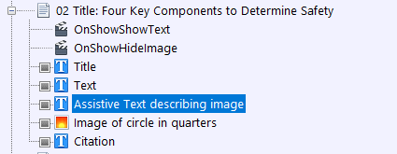

You will then size it so that if only that alternative shows, the slide makes sense. Assistive text and other assistive items should be check marked as “Initially Hidden”.

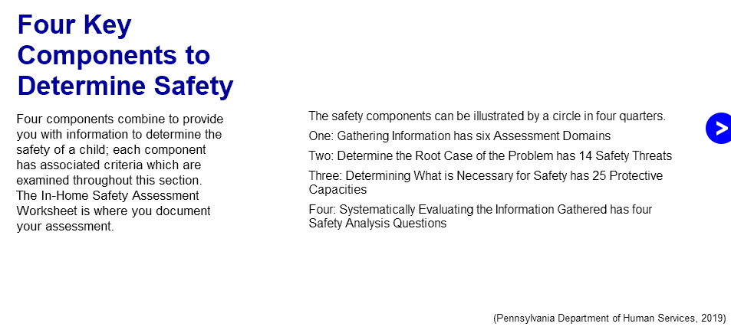
Next, set up the TE to hide the original graphic and show the accessible text if accessibility has been turned on.
On the page add an action “OnShowShowText” with a target of the assistive text
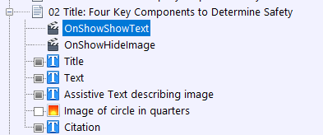
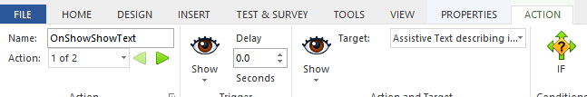
IF Variable is accessible, relationship is equal to, and value is 1.
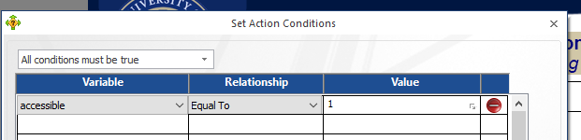
THEN add a second action to OnShowHide Image and Hide Target of Image.
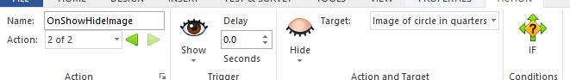
IF Variable is accessible, relationship is equal to, and value is 1.
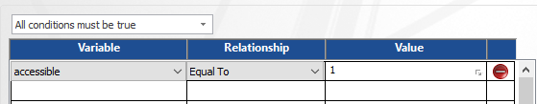
When the user selects “a” to activate the accessibility mode for a section, they will only access the revised slide with the accessible text. Users who have not activated accessibility, will access the original slide with the graphic. All users receive equitable information.

Keyboard Interface/QA Notes
Materials should be navigable with the keyboard and not require the mouse (This is one of many reasons for not using drag and drop questions). Do not use multipoint or path-based gestures for operation (You may know pathways as an unlock pattern on your phone where you draw a shape connecting certain does).
QA testing should include keyboard navigation (forwards and backwards), the use of a screen reader, as well as the traditional approach of testing all links and actions.

Language
Follow the word guidance at: https://pitt.sharepoint.com/sites/CurriculumTrainerDevelopment/Shared%20Documents/SD%20Private%20New/Curriculum%20Language%20Consistency.docx?web=1 Additionally:
  - Do not use we or us to refer to the CWRC; you may use you to refer to the participant.
  - Do not use contractions except in scenarios or for avatars
  - Use present tense
  - Use active (vs passive) language
  - For word emphasis use italics, not quotation marks
  - Indicate that race is self-identified
  - Use gender inclusive language rather than his/her
  - Ensure acronyms and abbreviations are spelled out for at least the first use
  - Provide definitions to technical terms
  - Avoid directional language for on screen items such as below or to the right
  - Avoid sensory words (unless required by the content or used by the source or law/policy) such as see, hear, read, click

Message Popups
In Lectora, you can create messages that are like text messages, in response to certain actions such as selecting an answer to a question or not selecting required buttons before selecting next. These buttons appear to be accessible for screen readers but should be tested. They need to be automatically read (not require manual selection to be read).

No Surprises! Rule
What’s that? No Surprises! means that the user will not accidentally or unknowingly navigate to another website, assessment, or even slide without manually selecting that option. It also means that the user must be able to get back to where they were before acting. They need to know that they are being offered a link/button etc. and what it will do before they select it.

PDFs
- Do not attach PDFs directly in Lectora (the functionality is unreliable in some browsers); send to tech for web hosting and link to a web address
- If linking to a specific page, use the following format: http://www.example.com/myfile.pdf#page=4 (Note: you can only reliably link to a pdf document that we are hosting)
- Directions for creating ADA accessible PDFs: https://pitt.sharepoint.com/:b:/s/EITWorkgroup/EaiXBmkziW9JuXVA84Cyu9YBexYNsk1HqjducmzGI66_pg?e=brIrHw
- End of module PDFs should be created prior to pilot (and updated periodically following major changes):
  - Ensure that popup chapter pages are in order within each section
  - Ensure that popup chapter pages are not replicated across sections and that all are used
  - Before creating the PDF, ensure that any accessibility mode items are showing (and that the images they replace are deselected in the Title Explorer); this allows the PDF to read the text vs requiring extensive manual tagging)
  - Lectora requires you to Print to PDF, so save the resulting file, then open in Adobe Pro and run the text recognition feature (then follow the directions in the third bullet)
  - In the resulting PDF, you manually move Popup Chapter Item Pages so that they follow the slide which links to them

Popup Chapter
Most of the rules that apply to main slides also apply to Popup slides. Continue to rename the objects, tag, and place the objects in read order. Remember to ensure that text is not used as an image unless there is an accessible alternative in use.
In the Title Explorer, begin each Popup Page with the slide number which links to the popup, and remove any unused popup slides.

Progress Bar
The Progress Bar is added via the template master page. Also note if you add any popup slides after tech has done their work, you will need to ensure that the Progress Bar excludes the Popup Chapter Title and all slides:
- On any page single click on the Progress Bar. Go to Properties and select Included Pages.
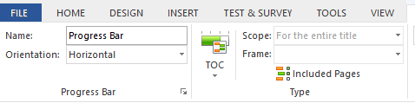
- Next select Included Pages and scroll down to the POPUPS chapter. Make sure that both the POPUPS chapter title and all popups are deselected. Otherwise, the progress bar will include them and not show the course as complete.
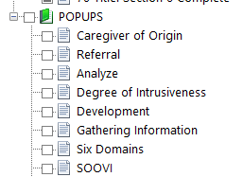

Read Order for Screen Readers and Tagging
Screen readers in Lectora read objects in the order in which they appear on each slide in the Title Explorer (TE). That means that there are several considerations for how you name and arrange items in the Title Explorer.
Changing read order is easy!
- Simply drag and drop each object into the order in which you want the screen to be read. Generally, it will be:
  - Title
  - Sub-title (if applicable)
  - Text
  - Accessible Text (more about these later)
  - Original popups or images
  - Citation

Responsive Design
For ADA compliance, responsive design should be used so that any device orientation will work. Strive to ensure that design can work on all views.
The tech department takes primary responsibility for responsive design after the CIS turns over the files to them.
Any time you make edits after tech has worked their magic, but sure to check ALL responsive design views and make necessary adjustments using the icons above your design window:
If an object cannot be viewed in portrait mode, tech will set up a notice to flip the screen to landscape mode. If possible, avoid this necessity as it is not ADA compliant.
If an object needs to be redesigned, such as reconfiguring a 6-column chart to work on a portrait phone, you may notice that there are objects off the page, in the wings. Do not delete those items as they will also delete from other views where they are in use.

Scrolling
Scrolling/scrollbars should only be used on one dimension; we only use vertical scrolling, never horizontal

Sectioning and Assessments
- If a participant is entering information that will need repopulate later as a reminder or to complete an activity, the original entry and follow-up slides MUST be in the same Lectora section; the system cannot access such information from a prior module/section
- Section numbers ARE used at the beginning of each section on the section title slides

Slide Layout
- Left align the text with the header, unless using a special design for the slide
- Always keep the next and back buttons in the same location
- If using a dictionary or case file link, try to keep the location the same from slide to slide

SuperNext
We are no longer using SuperNext, so if retroactively working on a file, on the master slide please delete SuperNext and OnShowShowSuperNext

Table of Contents
The Table of Contents is added via the template master page. Keep in mind that what you type in the Title Explorer for the page title is exactly what will populate the Table of Contents. Also note if you add any popup slides after tech has done their work, you will need to ensure that the Table of Contents excludes the Popup Chapter Title and all slides:
- On any slide, single-click on the Table of Contents to highlight it in TE.
- Then go to Properties and Included pages:
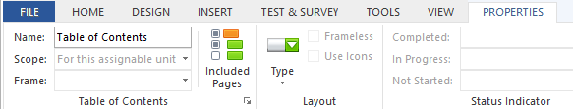
- Next select Included Pages and scroll down to the POPUPS chapter. Make sure that both the POPUPS chapter title and all popups are deselected. Otherwise, the TOC will include them.

Tests
- Tests such as Check Your Understandings should not involve images or must have the image AND equitably descriptive text
- Within Lectora, the following types of questions are accessible (but not necessarily recommended by the department):
  - True/false
  - Multiple choice
  - Multiple response
  - Rank/sequence
  - Fill in the blank
  - Number entry
  - Short answer
  - Essay
  - Likert (please only use one Likert scale per slide)
- Avoid drag and drop, hotspot, and image-based questions unless you build an alternatively accessible and equitable text-based version

Text Boxes
- When designing slides, try to put the information in as few text boxes as possible. For example, a bulleted list can be in the same text box as the introductory or follow-up text.
- Leaving a long quote or point of special interest in a formatted text box is fine
- When using a text box with a border or background color, ensure there is a margin (try 5) so that text is not harder to read by its proximity to the edge
- Try to enter text directly in a shape or text box, rather than on a text box over a shape (simplicity helps with ADA and responsive design)
- Key reviewers prefer left aligned text (vs centered) for text boxes
- Do not add blank lines at the beginning of text boxes

Timing
Do not add elements or tests with timing minimums or objects that proceed without user actions required (no automatically advancing text etc.). Do not require timing for keystrokes

Title Tagging
- In Lectora, the Title Explorer text equals the tags
  - Example: 03 Title: Competencies for Supervisors
    - The title tells the participant what the object is and what the priority is on the screen since they can’t see bold fonts, and then the complete title is the header and is descriptive
- Tagging in Title Explorer, Part 1: make your title match your slide titles; not only does Title Explorer populate the Table of Contents, it is what screen readers read! Use complete words.
- In Lectora, the Title Explorer text equals the tags
  - Example: 03 Title: Competencies for Supervisors
  - Title tells the participant what the object is and what priority on the screen since they can’t see bold fonts, and then the complete title is the header and is descriptive
- Slide titles as labeled in the Title Explorer populate the dropdown Table of Contents. Title each slide in the Title Explorer with the slide number, Title: and the spelled-out slide title, matching the actual title if possible. Be sure the title in the TE matches the actual slide title.
- Title Explorer has a 128-character limit, so you may need to make some adjustments.
- Screen readers read text in the order as listed in Title Explorer. Both reasons mean that titles, objects, and images, etc. all need to be named clearly and uniquely on each slide.
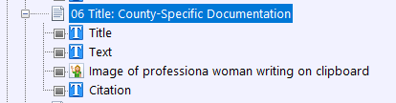
- For example, you do not want multiple items labeled with the same title on the same slide. (See Curriculum ADA Implementation 7/7/2020 for information on labeling images).
Screen readers do not differentiate between a bold header and body text. We have to indicate in the Title Explorer that an item is a slide title; we do so by naming each “Title”. Do not spell out the slide title; the reader will read the text in the title text box.
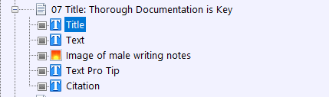
Label text boxes simply as Text, unless it is something special like a Pro Tip, Quotation, or Example:

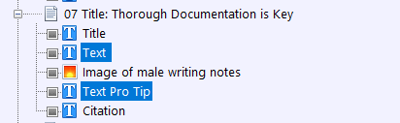

Transitions
Ensure there are transitions between slides when topics change and between all sections. These may be light recaps of progress and an introduction to what is next

