CWRC

Lectora Style Guide and ADA Updates
Contents
All about COLOR! 3
Ampersand 7
Animations 7
Audio/Video 7
Avatars 7
Bulleted Lists 8
Buttons, Hyperlinks, Images Used as Links & User Actions 9
Buttons – Requiring 10
Buttons – Requiring Multiple 11
Button States 12
Captioning 13
Charts 13
Checkboxes 14
Checking Files in and Out of Lectora Online 14
Conveying Meaning through Non-Text 14
Create New Pages in the POPUP chapter 15
Drag and Drop 16
Dropdown Menus 16
Font and Line Spacing 16
Forms 16
Headers, Sub-Headings, Special Notes etc. 16
Hide from Screen Reader 17
Hover 17
Images 17
Tagging Images Basics 17
Decorative Images or Elements 18
Master slide items 18
Creating Accessible Text Descriptions 18
Assistive Text Equivalents: Replacing a Complex Image, Infographic, or Chart 19
Initially Hidden Items – in Lectora Online 22
Keyboard Interface/QA Notes 23
Language 23
Message Popups/If… Then Display Message 24
No Surprises! Rule 24
PDFs 24
Popup Chapter 28
Progress Bar 28
Read Order for Screen Readers and Tagging 29
Changing read order 29
Responsive Design 30
Scrolling 30
Sectioning and Assessments 30
Slide Layout 30
Speech Bubbles 31
SuperNext 32
Table of Contents 33
Tests 33
Text Boxes 34
Timing 34
Title Tagging 34
Transitions 36

Note: some screen shots were taken before line spacing and font were adjusted- be assured that 1.5 line spacing, with 12 points after each paragraph is the rule despite the images. In time, these will be updated.

All about COLOR!
- Ensure color contrasts are compliant
  - Contrast ratio of at least 4:5 (except for large text which requires 3:1, incidentals, or logotypes)
- Use an online checker – check out Tanaguru and Deque:
  - Tanaguru: https://contrast-finder.tanaguru.com/result.html?foreground=%23000000&background=%23ffb81c&ratio=4.5&isBackgroundTested=false&algo=Rgb
  - Example: Enter codes for black (0,0,0) and gold (255,184,28). Select Minimum Ratio of 4.5 and then Check and find contrast:
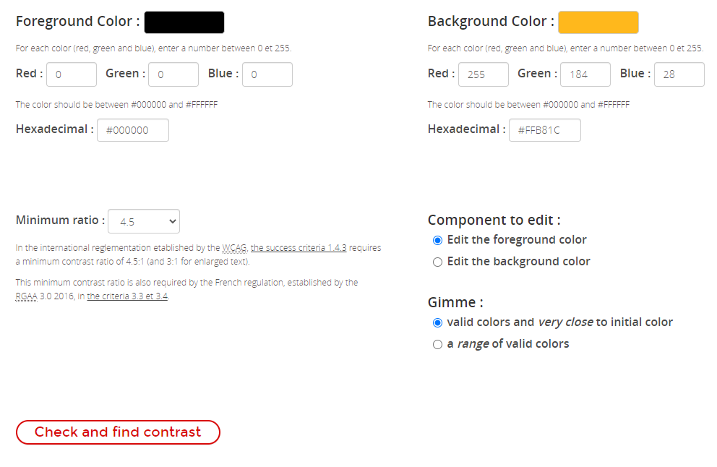

Scroll down for the following results:
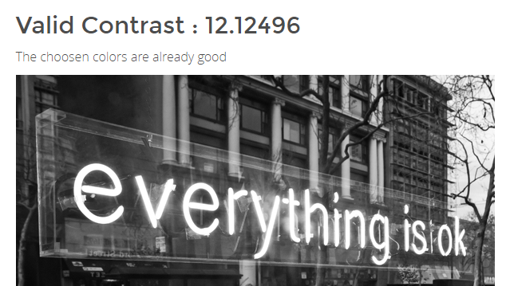
If your example is not good such as with the following:
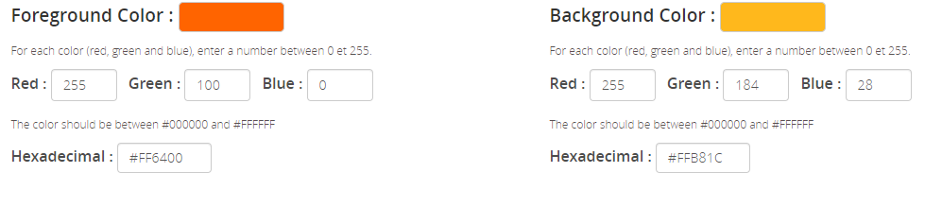
You will get the following results, which indicate a contrast ratio of only 1.7138, which is not compliant:
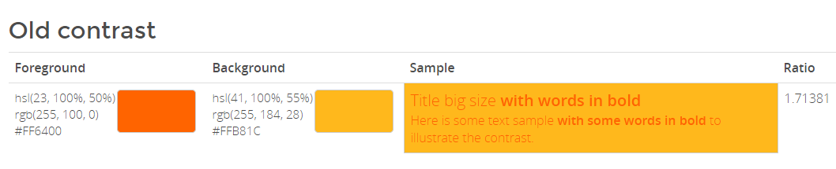
  - Deque Color Contrast Analyzer: https://dequeuniversity.com/color-contrast
    - The Deque University tool includes sliders to adjust your color so you can see what a close option to what you were trying would look like as you select ADA compliant color contrasts. The tool also states if the colors pass the AA or AAA standards (we are to meet the AA standard, at a minimum)
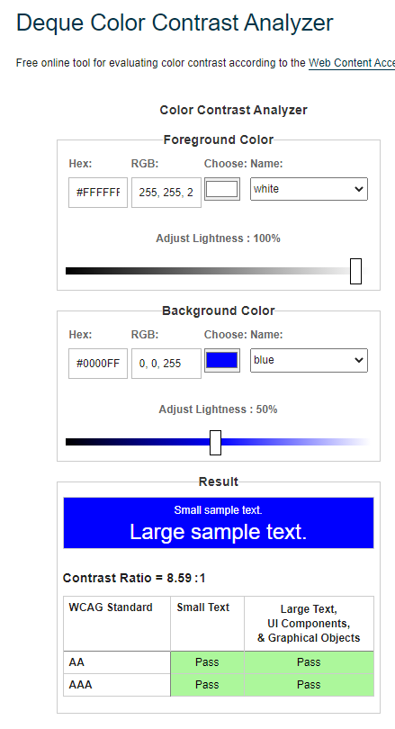
- Go to our Pitt color cheat sheet for which Pitt colors are to be used with white or black fonts: https://pitt.sharepoint.com/:w:/s/CurriculumTrainerDevelopment/ERLpN6ptWkNFml1jK2OBlZMBRdgPtcso4VFPN4R76J4PdA?e=XcRFw6&CID=14531EDC-EFAB-49DE-9256-E7AC55DDD760&wdLOR=c2B2E9324-3F91-412F-9C0E-1AF01B178E03
- Research shows that for many with autism, yellow is disturbing – use with care
- Avoid using red for bad; green for good (red and green are most common issues for color blindness)
- Avoid using color for meaning if possible
  - We’ll cover how to keep colors with meaning AND make access equitable in a future update! In the meantime, if you are using color to indicate meaning, please contact Jenny for a workaround.

Ampersand
Try to avoid using the ampersand symbol (&) unless it is used in a source – it’s easier for learners using screen readers to hear and then to hear ampersand.

Animations
Do not use on screen animations such as moving or flying in, fades, or flashing.

Audio/Video
- Audio and video must not automatically play (the learner must activate the play function), and the user must be able to pause, stop, and adjust volume on the audio or video recording. (The auto play function interrupts a screen reader.)
- Video with audio must have synchronous captioning (process TBD)
- If VISUAL actions occur in a video that are important, the actions must be described in the captioning and convey equitable meaning
- If there are sounds in audio that add to the meaning of the words in the transcript, the sounds must be described in the transcript to provide equity
- For audio, ensure that foreground speech is clear with no background noises

Avatars
When you are selecting an avatar consider if the poses and outfit are adequate to meet your design, diversity, and representation needs.
To add an avatar in Lectora Online go to Tools, Stock Assets, Stock Images and Vectors, search for “cutout people”. Filter for standard products in left menu, along with any other applicable filters.
Visually, avatars should not be mini on the screen compared to other content. Instead, crop and zoom in following the suggestions for cropping at: https://digital-photography-school.com/good-crop-bad-crop-how-to-crop-portraits/ (primarily don’t crop through any joints). Also try to avoid floating avatars.
Avatar quotes should be concise, use first-person language, and use contractions. It is better to split an avatar’s speech over multiple slides than to overfill a slide. See Speech Bubbles for more information.
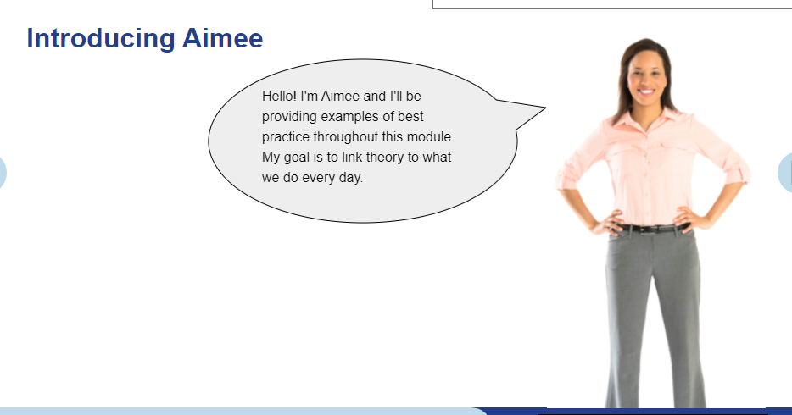

Bulleted Lists
- 1.5 line spacing
- Indented one setting from main text (not entered in a separate text box)
- Not complete sentences or end in periods if possible
- Between intro sentence and bullets and among bullets, 1.5 line spacing NO extra spacing after paragraphs/DO NOT USE HARD RETURNS TO ADD BLANK SPACES BETWEEN PARAGRAPHS
- After bullet list before next paragraph, 12 pt
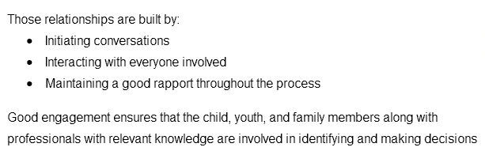

Buttons, Hyperlinks, Images Used as Links & User Actions
- Whenever asking the participant to do something (select a link, button, image, save, print etc., clearly state the directions on the slide, do not reference direction such as below, do not use the word “click”, and use a colon as in the following example:
  - Please select the button for more information about the Family Service Plan:
- Anything acting as a button or hyperlink needs to be labeled in Title Explorer as what they are and include what they will do
  - For example: Button to PA Child Welfare Practice Model web page
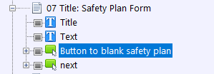
(The bottom next button is the one with conditional formatting that requires the safety plan button be used to proceed; you do not need to further define the button. On old courses, please rename the bluestampback and bluestampnext buttons to simply back or next).
- Balance brevity with clarity
- By providing direction you are helping to meet the No Surprises! Rule (reference section by that title)
- Within each module (or even series) use consistent button styles (while ensuring that color contrast and font size meet ADA criteria) -
- Only use a few buttons per slide – for more information, consider creating a job aid that can be saved or printed (a win-win situation, fewer buttons to select, less repetition, and more job aids!)
- Do not use a button as a text box or for decorative text. The screen reader will expect an action to be taken and the button will have a hover state. Instead, create and modify a text box to achieve the desired visual effect (which should not imitate a buttons appearance).

Buttons – Requiring
Generally, when we use buttons for the first time, we require users to select it:
- Copy a Next button and paste it on the page on which you are requiring an action.
- Page properties, Inherit Settings, Exclude inheritance of certain objects – select the Next button on the Inherited list and hit the triple arrow to it moves to the Excluded list. Select Ok.
- Select the button you wish to require
  - Action tab: 1 of 2 should list the go to action (such as to website, popup etc.)
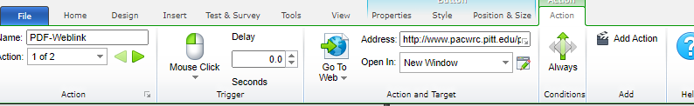
  - 2 of 2: On Mouse Click, Modify Variable, Target: 10Competencies Clicked (rename descriptively); Type Set Equal To: Value 1; Always.
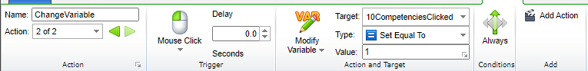
- Select the pasted next button
  - Action Tab, On Mouse Click, Go To, Next Page, IF, All Conditions Must be True, Variable (entered), Relationship Equal to, Value 1. Select OK.
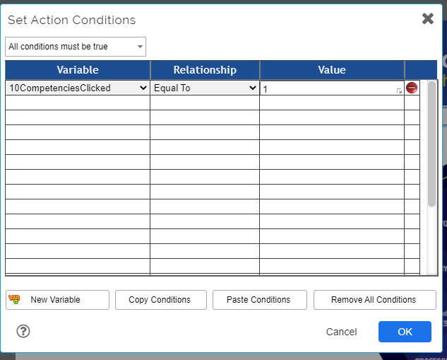
Set Display Message to: “Select the button before proceeding.”
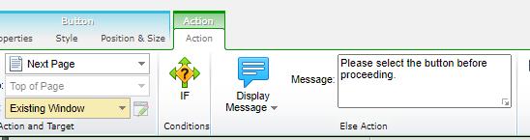

Buttons – Requiring Multiple
Repeat step for Button – Requiring for each button. The Action IF tab for the next button should be set to “All conditions must be true” and list a variable, relationship, and value for each required action:
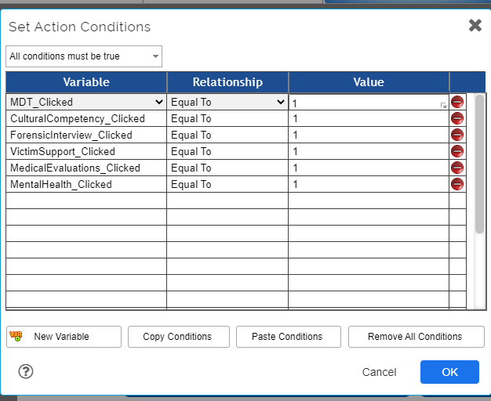
Set Display Message to: “Please select all 6 buttons before proceeding.” (adjusting accordingly)
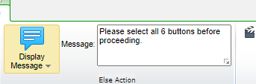

Button States
If you wish to indicate that a button has already been activated, use high contrast (see All About Color section) or an icon. Do not use low contrast or hover states.

Captioning
Videos with audio must include synchronous- closed captioning. (As of 3/15/21, procedures are being developed). See Audio/Video.

Charts
Do not copy charts created in other programs into Lectora, as that is inserting text as an image, which is to be avoided whenever possible. Instead, build simple and small charts in Lectora using the Tables function. Screen readers will be able to access and relay the text in the chart. Here is a sample Lectora chart with some learning points included:
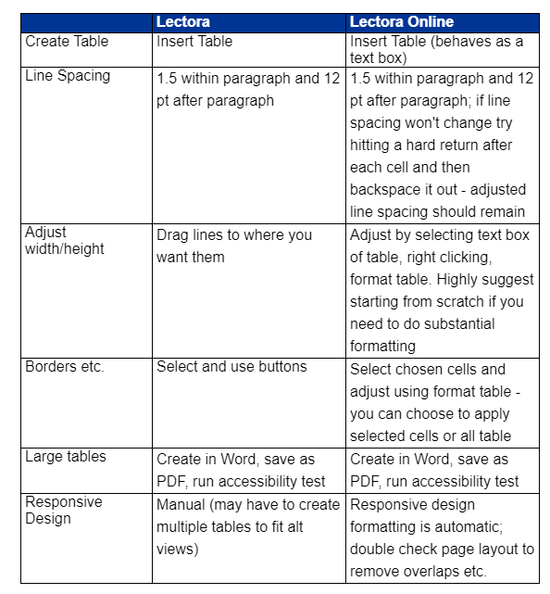
Larger, more complicated charts should be built and tagged in Word or Excel, saved as a PDF, run the accessibility checker, and link out to the web-hosted PDF.

Checkboxes
For multiple choice questions or similar items use the ZESTY checkbox/button design; this ensures that the target for pointing or selection is accessible (highly visible and easy to activate).

Checking Files in and Out of Lectora Online
When using Lectora online you must check files, chapters, or objects before editing them so that multiple users don’t create conflicts. Once you open a file, at the top of the Title Explorer select the Title of the course so it is blue and then select the Green left arrow. If you have not selected the title (or chapter or object) you won’t have the option to check out or in any object. You must select something.
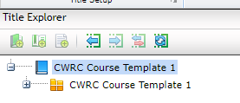
To check the title, chapter, or object back in, select the item and then the right green arrow.
If multiple users are working in a file you can hit the right button which is solid green with a white reloop arrow to update checkin/out status.
When something is checked out to someone else, there is a red square around it in the Title Explorer. If you hover over the square it displays the email address of the person who has it checked out. If you have something checked out, the square is green.

Conveying Meaning through Non-Text
Do not use only non-text elements to convey meaning (reference All About Color! for more information)
- Single sensory characteristics such as shape, color, size, locations, orientation, or sound are to be avoided
- Instead, use multiple sensory characteristics to convey information such as color AND an icon, a blue-underlined hyperlink in addition to ensuring that any information conveyed only through visuals are also equitably described in the accessibility alternative.
  - For example, a flowchart often uses shapes, color, font, and directional arrows to convey process or decision-making information. None of those approaches are ADA compliant but can be useful to many participants. Instead of removing or not using a flowchart or infographic, you need to provide an alternative such as a text description of the decision-making process and steps. (Refer to Creating Accessible Text Descriptions under Images for more information.)

Create New Pages in the POPUP chapter
- Set your button, image, or hyperlink settings to: New Window, select the window icon then Popup Window, New Browser Window, and ensure that the lower four HTML Only Preferences are checked: No Menubar, No Status Bar, No Toolbar, and No Location Bar.
- You can deselect Inherit Page Size on the popup page and resize the page to better fit your new popup
- If you are copying a pre-existing text box that was initially hidden to a POPUP slide, be sure to uncheck Initially Hidden or your popup slide will remain blank.
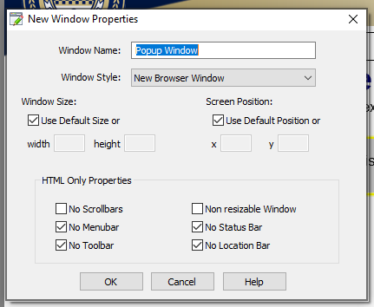

Drag and Drop
Do not use drag and drop features; you can redesign multiple choice questions to have a similar effect. Drag and drop designs are not ADA compliant as they require manipulation.

Dropdown Menus
Do not use drop down menus (except for our template Table of Contents). Dropdown menus are not ADA compliant as they require manipulation.

Font and Line Spacing
- Slide Title Font remains at Arial, Bold, 28 pt, Blue
- Body Font (must be a minimum of) Arial, 12 pt, 1.5 line spacing, with 12 points after each paragraph
- Citations are Arial, 12, black font

Forms
- If you are including a form for reference (not completion) or as a pre-completed scenario example, include a link to the form as a OCRs PDF NOT as a pasted image or printed PDF
- If you are including only a portion of the form either recreate it as a table in Lectora or link to it in an accessibility checked (and corrected) PDF
- If you are including a form that must be completed by the participant, work with the Tech Department

Headers, Sub-Headings, Special Notes etc.
Headers, and sub-headings, special notes, warnings, and images used as sub-headings (such as PA Child Welfare Competency graphics) must all be tagged with the level in Title Explorer (screen readers won’t recognize that you have bolded something to give it sub-header status, so you convey that information with the Title Explorer; you need to indicate the relationships of the text and objects to each other in an additional means than just the visual)

Hide from Screen Reader
A text box may be hidden from a screen reader; it’s the same idea as applying “Empty alt-tag” to a purely decorative image. Simply select the text box and then the checkbox for “hide from screen reader”. You might want to do this if there is a repeated subtitle or chapter reiteration on a series of related slides and it would be annoying to the listener to hear the same information repeatedly.

Hover
Do not use hover features to trigger additional content, motion, or anything else

Images
Ensure pictures have the same feel throughout a module or series; generally, avoid cartoons except for well-designed avatars

Tagging Images Basics
- Check default alt tags for images - not all default tags for images are actually descriptive
  - Example: The default image tags are often named by the source or numbers; rename them to indicate content
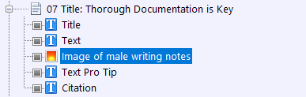
- Another thought about images: "If you can’t write good descriptive text then you probably don’t need that image. If you don’t know how to describe it, then you don’t need it." (Bozarth 2019)
- Descriptive text does not need to be detailed; convey what is adding meaning. (For example, you don’t need to say that Shreya is wearing a teal shirt; however, if Shreya were wearing a t-shirt with a slogan that adds to the meaning, you would include that information.)
- If an image conveys meaning create an alt-tag; please do not use empty alt-tags for items with meaning
Decorative Images or Elements
Note, if you have an image or element (such as a line) that is purely decorative and does not add meaning, consider if you really need the object.
- If you do not need the object, delete it.
- If you do need the object because it adds a decorative element but not meaning, then change the properties to “empty ALT tag”. Doing so instructs the screen reader to skip over mentioning the decorative object.
- Do one of the following to display the Properties ribbon:
  - In the Title Explorer, double-click the graphic of the object.
  - In the Title Explorer, right-click the graphic and select Properties.
  - In the work area, double-click the object.
  - In the work area, right-click the object and select Properties.
- In the Web Options group, enable the Empty ALT Tag check box.
- Images should be placed in the order in the Title Explorer so that the reader will address the image in the context that makes the most sense.
- If your image adds meaning and you can describe what it is or means in 128 characters or less, rename the image as “Image of…” and provide the meaningful details
Master slide items such as the University of Pittsburgh title and shield and footer information. Our template is being adjusted so screen readers will not repeat this information.

Creating Accessible Text Descriptions
Screen readers cannot read images even if they include charts or text. That means we need to create alternative access to keep the screen-read course equitable. There are two options:
- The first is to redesign the slide so there are no complex images and there is no text in images. You may not wish to sacrifice engagement and design considerations.
- The second option is to add a text box to explain the content in a way that the screen reader can access, but that is invisible to non-screen reader users. Proceed for an example applying the second approach:

Assistive Text Equivalents: Replacing a Complex Image, Infographic, or Chart
Note: for the following to work, settings must be added to the master slide; tech will do this for the retroactive slides and to future templates (or you can try copying the accessibility functions from an updated course such a Foundations Module 4, Section 6 as shown here; note, all sections need to contain the accessibility additions:
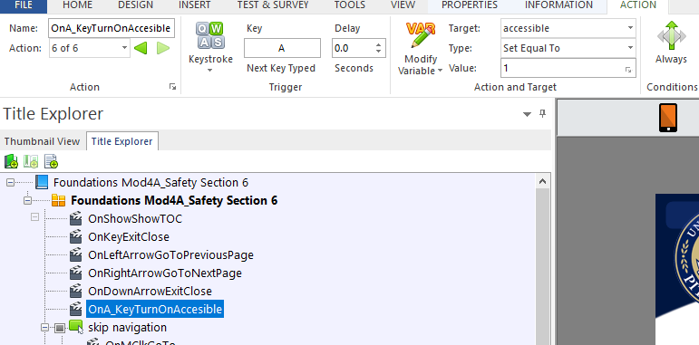
Sometimes you will have a complex image, infographic, chart, or other object that cannot be explained in 128 characters or less, but you still need to equitably relay the meaning. In these cases, the user of assistive technology does not need the original item at all. Rather, they need the text equivalent.
Consider this image:
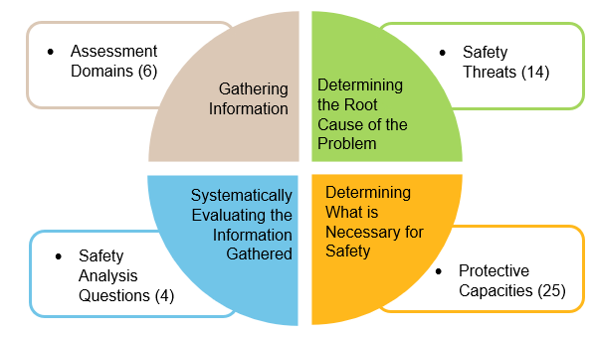
All of the relevant information would take more than 128 characters to relay, so we cannot just rename the tag in the TE. (Line spacing was not changed in the graphic is it will not show in accessibility mode).
Instead, create a text box with the text alternative and name it “Assistive text…”

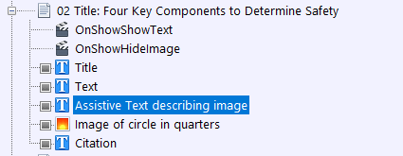

Then size it so that if only that alternative shows, the slide makes sense. Assistive text and other assistive items should be check marked as “Initially Hidden”.

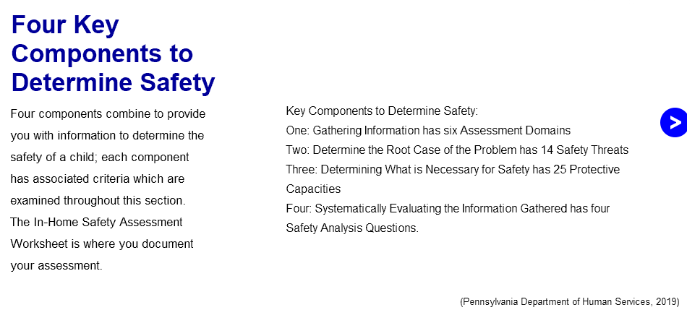
Next, set up the TE to hide the original graphic and show the accessible text if accessibility has been turned on.
On the page add an action “OnShowShowText” with a target of the assistive text
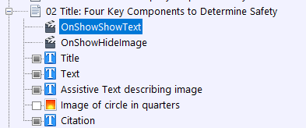
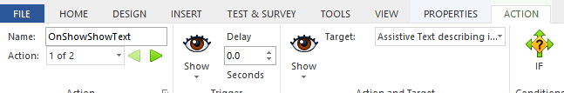
IF Variable is accessible, relationship is equal to, and value is 1.
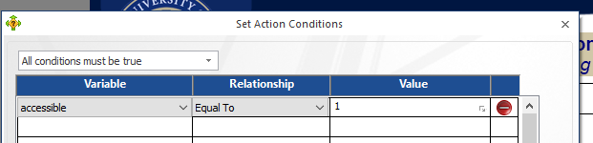
THEN add a second action to OnShowHide Image and Hide Target of Image.
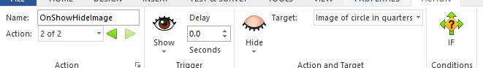
IF Variable is accessible, relationship is equal to, and value is 1.
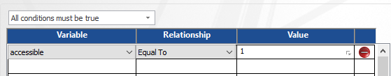
When the user selects “a” to activate the accessibility mode for a section, they will access the revised slide(s) with the accessible text in place of originals with complex graphics. Users who have not activated accessibility will access the original slide with the graphic. All users receive equitable information.

Initially Hidden Items – in Lectora Online
Some text boxes are initially hidden so that an action, such as selecting a button, makes a popup appear. Initially hidden objects CAN be read when created in Lectora Online IF the user takes a specified action to make it appear. DO NOT USE initially hidden for anything that does not require a user action. (If you are editing in Lectora Desktop, do not use the Initially Hidden feature as it will not be accessible). Keep in mind that initially hidden items may not appear or may overlap each other in module PDFs, so consider layout and what information must still be relayed in the PDF.

Keyboard Interface/QA Notes
Materials should be navigable with the keyboard and not require the mouse. (This is one of many reasons for not using drag and drop questions). Do not use multipoint or path-based gestures for operation. (You may know pathways as an unlock pattern on your phone where you draw a shape connecting certain does).
QA testing should include keyboard navigation (forwards and backwards), the use of a screen reader, as well as the traditional approach of testing all links and actions.

Language
Follow the word guidance at: https://pitt.sharepoint.com/sites/CurriculumTrainerDevelopment/Shared%20Documents/SD%20Private%20New/Curriculum%20Language%20Consistency.docx?web=1 Additionally:
  - Do not use we or us to refer to the CWRC; you may use you to refer to the participant.
  - Do not use contractions except in scenarios or for avatars
  - Use present tense
  - Use active (vs passive) language
  - For word emphasis use italics, not quotation marks
  - Indicate that race is self-identified
  - Use gender inclusive language rather than his/her
  - Ensure acronyms and abbreviations are spelled out for at least the first use
  - Provide definitions to technical terms
  - Avoid directional language for on screen items such as below or to the right
  - Avoid sensory words (unless required by the content or used by the source or law/policy) such as see, hear, read, click

Message Popups/If… Then Display Message
In Lectora, you can create messages that are like text messages, in response to certain actions such as selecting an answer to a question or not selecting required buttons before selecting next. These messages are ADA compliant.

Module Title
When you create or copy a Lectora file you need to rename it several places:
- The actual file name
- In Title Explorer at Book level
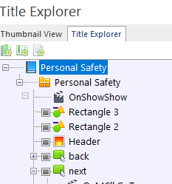

- In Title Explorer at Master Slide Level
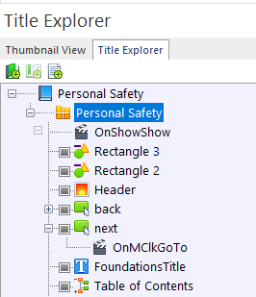
Title Explorer names affect how items show in ReviewLink and how they are named in the exported files that are converted to PDFs.

No Surprises! Rule
What’s that? No Surprises! means that the user will not accidentally or unknowingly navigate to another website, assessment, or even slide without manually selecting that option. It also means that the user must be able to get back to where they were before acting. They need to know that they are being offered a link/button etc. and what it will do before they select it. This is why button objects are named as “Button to CWRC website homepage”.

PDFs
- Do not attach PDFs directly in Lectora (the functionality is unreliable in some browsers); send to tech for web hosting and link to a web address
- If linking to a specific page, use the following format: http://www.example.com/myfile.pdf#page=4 (Note: you can only reliably link to a page of a pdf document we host)
- Directions for creating ADA accessible PDFs (from Word, Excel etc.): https://pitt.sharepoint.com/:b:/s/EITWorkgroup/EaiXBmkziW9JuXVA84Cyu9YBexYNsk1HqjducmzGI66_pg?e=brIrHw
- End of Lectora module PDFs should be created prior to pilot if possible, and definitely before launch (and updated periodically following major changes):
- Open Lectora File (begin with Section 1 if there are multiple sections)
- If applicable, go through Lectora file and ensure that accessible text shows, NOT the image/graphic and ensure there is no overlapping information. You should be able to identify any slides with accessible text by expanding the slides information in the Title Explorer and looking for objects labeled accessible.
- For example, this slide has accessible text as an alternate to the image with text and all items are showing because they’re checked off on the TE:
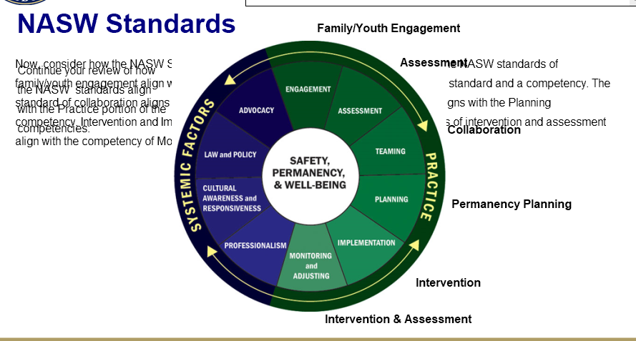
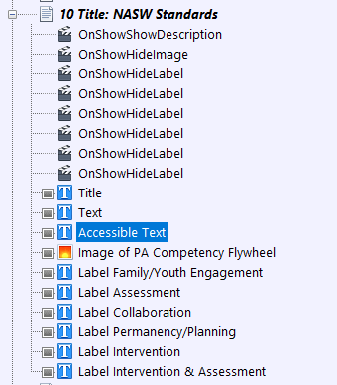
- In order to show just the accessible text, deselect the text boxes for everything else that wouldn’t be used on the accessible slide (Doing so sets up the file to send only the desired text into the word document (that you’ll later turn in to a PDF). Don’t worry - you can add any necessary images back in to the Word document).
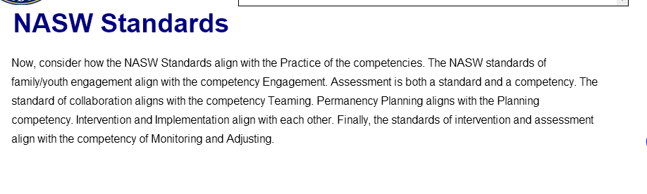
- File, Export, Word: rename title and location to be saved (desktop – final destination will be the module’s curriculum Sharepoint folder), Save, OK
- Open file using Word. (Your images will be missing. We’ll get there next).
- *Delete mod information on each slide: (unfortunately, deselecting these items in TE does not prevent them from exporting into the Word doc):
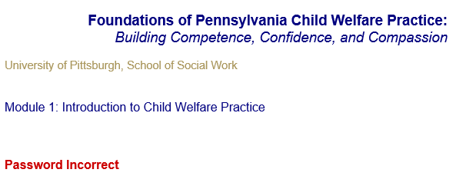
- Change document layout to landscape (in section 1 only; other sections will be pasted in).
- *Cut and Paste text from popup slides so that the information appears in order in the Word document for the first section (example: a button is on a slide, paste the popup information that the button links to next)
- *Compare Lectora slides to pages in the Word document.
  - *If a picture is necessary to add meaning, snip the image in the Lectora file and paste it into the Word doc. If necessary, add some text in paragraphs or via alt text to explain it for users who may be using assistive technology (adding text now is easier than tagging in Adobe).
    - Adding Alt text to an image: right click, format auto-shape/picture OR picture, alt-text tab, enter description, select OK
  - *(IF a button goes to a website, insert a button once you have created the PDF and link it to the website. However, the PDF is not considered the primary vehicle for learning; it is a backup aid which we want to be accessible. It does not need to be fully equivalent as our primary courses are (or will be soon).
  - *Hyperlinks appear to carry over to the Word document- they do not; you will need to copy the web address and insert the link in the Word doc. IF a hyperlink goes to a popup, remove the appearance of the hyperlink formatting and insert the popup slide information after the Word page that would have linked to it
  - *If object order is incorrect in Word, check the TE reading order and correct in Lectora and manually in Word.
- Run and open section 2 and repeat formatting above as marked with asterisks.
- Then select entire section in Word and paste to the end of the prior section which you have already formatted (page layout etc. should automatically apply to the pasted text).
- Repeat for each section until all content is in the Word document. Save often.
- Turn on reveal codes and clean up line spacing and remove all extra hard-line returns. (Turn off reveal codes).
- Highlight the first heading in your word document and set it as a custom style by selecting the square and arrow to the lower right of the Styles section on the Home tab. Then select A+ and name your style Header.
- Then select each slide header and select the Header style (or once you did it, you can hit CTRL+Y to repeat the prior action). (Screen readers cannot identify bold font; applying the styles in Word makes them more accessible).
- Next, go through the document checking for images or any other text that requires refinement:
  - Check spacing- you may find that text continues onto a second page because there are empty returns at the top; also, text boxes that you had used as labels will be retained and may need to be deleted when the accessible text is used instead of the image.
  - Responsive design items: Text items that are not on the main view and were created for responsive design will ALL export into the Word Doc. You will need to delete the duplicate items and responsive design instructions.
  - You may find mistakes in the Lectora file based on evidence in the Word document (for example, the Word doc puts items in the Title Explorer orders, so if something is amiss in Word, you’ll need to adjust it in Lectora). Simply make the changes in both files. Be sure to let Tech know if any Lectora files need to be reuploaded.
- Add a footer containing the module title, creation date, and page number.
- File Save As PDF, choose location (desktop), and rename and date the PDF file.
- Open the document in Adobe Pro and run the accessibility checker (Tools, Accessibility, Full Check, Start Checking), correcting any issues in the Word Document, then resaving as PDF, and running the checker again.
- Upload the PDF file to the curriculum Sharepoint site for the module and email the PDF to tech along with the website link location for the course PDF OR ask them to reply to you with a link if it’s new so you can add it to the course.
- Also save the Word document to the course site – that way when edits are made, you don’t need to redo everything.

Popup Chapter
Most of the rules that apply to main slides also apply to Popup slides. Continue to rename the objects, tag, and place the objects in read order. Remember to ensure that text is not used as an image unless there is an accessible alternative in use.
In Title Explorer, begin each Popup Page with the slide number which links to the popup, and remove any unused popup slides.

Progress Bar
The Progress Bar is added via the template master page. Also note if you add any popup slides after tech has done their work, you will need to ensure that the Progress Bar excludes the Popup Chapter Title and all slides:
- On any page single click on the Progress Bar. Go to Properties and select Included Pages.
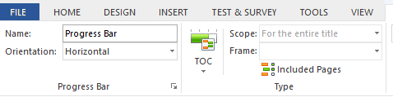
- Next select Included Pages and scroll down to the POPUPS chapter. Make sure that both the POPUPS chapter title and all popups are deselected. Otherwise, the progress bar will include them and not show the course as complete.
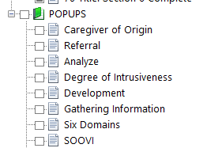

Read Order for Screen Readers and Tagging
Screen readers in Lectora read objects in the order in which they appear on each slide in the Title Explorer (TE). That means that there are several considerations for how you name and arrange items in the Title Explorer.
Changing read order is easy!
- Simply drag and drop each object into the order in which you want the screen to be read. Generally, it will be:
  - Title
  - Sub-title (if applicable)
  - Text
  - Accessible Text (more about these later)
  - Original popups or images
  - Citation

Responsive Design
For ADA compliance, responsive design should be used so that any device orientation will work. Strive to ensure that design can work on all views.
Responsive design is fairly automatic in Lectora Online but all alternate views of every slide should be checked before pilot, after any revisions, and before launch by using the icons above your design window:
If an object cannot be viewed in portrait mode, tech will set up a notice to flip the screen to landscape mode. If possible, avoid this necessity as it is not ADA compliant (this is much less necessary in Lectora Online).
If an object needs to be redesigned, you may ask tech for assistance. For redesigns you may notice that there are objects off the page, in the wings. Do not delete those items as they will also delete from other views where they are in use.

Scrolling
Scrolling/scrollbars should only be used on one dimension; we only use vertical scrolling, never horizontal.

Sectioning and Assessments
- If a participant is entering information that will need repopulate later as a reminder or to complete an activity, the original entry and follow-up slides MUST be in the same Lectora section; the system cannot access such information from a prior module/section
- Section numbers ARE used at the beginning of each section on the section title slides

Slide Layout
- Left align the text with the header, unless using a special design for the slide
- Always keep the next and back buttons in the same location
- If using a dictionary or case file link, try to keep the location the same from slide to slide

Speech Bubbles
When using speech bubbles for avatars or scenarios use the same font and spacing: Arial 12, 1.5 line spacing, 12 pt spacing after paragraph. Create the speech bubble and enter text on a text box above the bubble. Adding and layering boxes are not ideal, but the formatting in the speech bubble is limited (you can bold and underline, but you cannot adjust line spacing).
When designing your slides, speech bubbles should be fairly concise and use first-person language and contractions. For longer quotes, split the information over several slides as they are in comic strips. Visually, the speech bubble should not cover more of the page than the avatar. To adjust those proportions, you can shorten the speech bubble or zoom in on and crop the avatar.
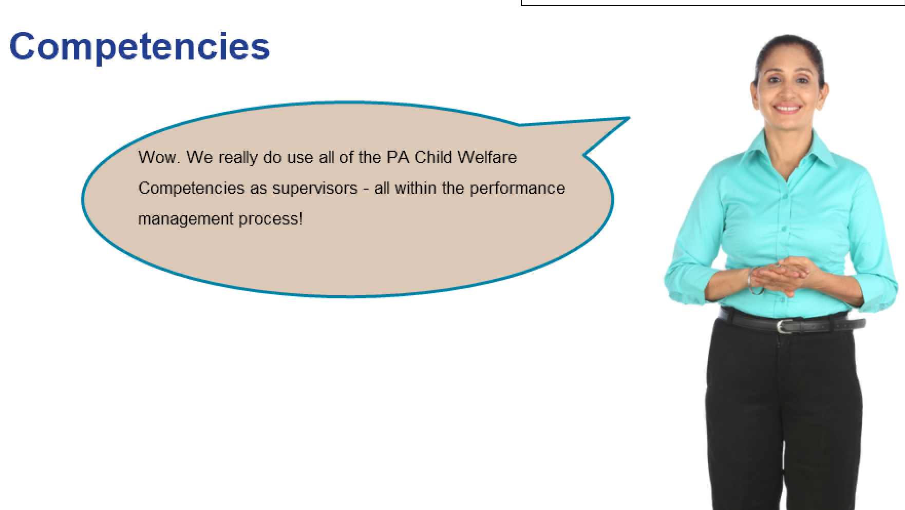
In Title Explorer:
- Adjust read order
- Callout Ellipse as empty alt-tag
- Name Text box as Text, Avatar Name or Role, and speaking such as, “Text Shreya Speaking” (Communicates via the assistive reader that the object is text and who is doing what without asking the learner to hear “Callout Ellipse” repeatedly)
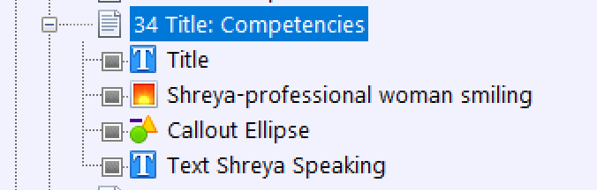

When possible, all slides should have titles. If you have an avatar series with no titles – be sure to name the slide in the title explorer with meaning such as 23 Title: Damian’s Example Continues, remember that this item is read by screen readers and populates the Table of Contents.
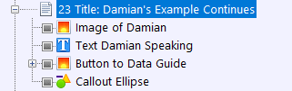
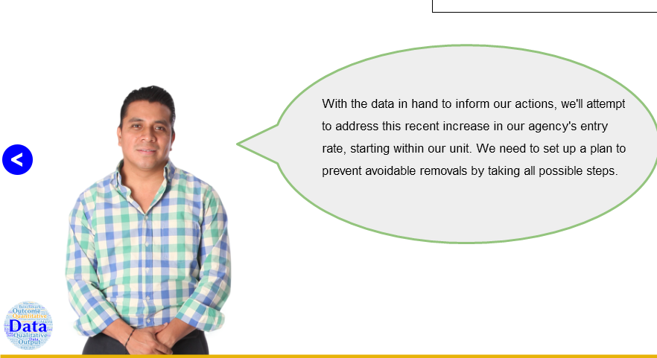

SuperNext
We are no longer using SuperNext, so if retroactively working on a file, on the master slide please delete SuperNext and OnShowShowSuperNext

Table of Contents
The Table of Contents is added via the template master page. Keep in mind that what you type in the Title Explorer for the page title is exactly what will populate the Table of Contents. Also note if you add any popup slides after tech has done their work, you will need to ensure that the Table of Contents excludes the Popup Chapter Title and all slides:
- On any slide, single-click on the Table of Contents to highlight it in TE.
- Then go to Properties and Included pages:
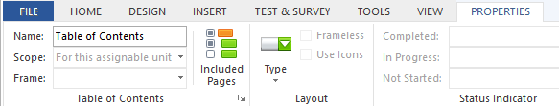
- Next select Included Pages and scroll down to the POPUPS chapter. Make sure that both the POPUPS chapter title and all popups are deselected. Otherwise, the TOC will include them.

Tests
- Tests such as Check Your Understandings should not involve images or must have the image AND equitably descriptive text
- Within Lectora, the following types of questions are accessible (but not necessarily recommended by the department):
  - True/false
  - Multiple choice
  - Multiple response
  - Rank/sequence
  - Fill in the blank
  - Number entry
  - Short answer
  - Essay
  - Likert (please only use one Likert scale per slide)
- Avoid drag and drop, hotspot, and image-based questions unless you build an alternatively accessible and equitable text-based version

Text Boxes
- When designing slides, try to put the information in as few text boxes as possible. For example, a bulleted list can be in the same text box as the introductory or follow-up text.
- Leaving a long quote or point of special interest in a formatted text box is fine
- When using a text box with a border or background color, ensure there is a margin (try 5) so that text is not harder to read by its proximity to the edge
- Try to enter text directly in a shape or text box, rather than on a text box over a shape (simplicity helps with ADA and responsive design)
- Key reviewers prefer left aligned text (vs centered) for text boxes
- Do not add blank lines at the beginning of text boxes

Timing
Do not add elements or tests with timing minimums or objects that proceed without user actions required (no automatically advancing text etc.). Do not require timing for keystrokes

Title Tagging
- In Lectora, the Title Explorer text equals the tags
  - Example: 03 Title: Competencies for Supervisors
    - The title tells the participant what the object is and what the priority is on the screen since they can’t see bold fonts, and then the complete title is the header and is descriptive
- Tagging in Title Explorer, Part 1: make your title match your slide titles; not only does Title Explorer populate the Table of Contents, it is what screen readers read! Use complete words.
- In Lectora, the Title Explorer text equals the tags
  - Example: 03 Title: Competencies for Supervisors
  - Title tells the participant what the object is and what priority on the screen since they can’t see bold fonts, and then the complete title is the header and is descriptive
- Slide titles as labeled in the Title Explorer populate the dropdown Table of Contents. Title each slide in the Title Explorer with the slide number, Title: and the spelled-out slide title, matching the actual title if possible. Be sure the title in the TE matches the actual slide title.
- Title Explorer has a 128-character limit, so you may need to make some adjustments.
- Screen readers read text in the order as listed in Title Explorer. Both reasons mean that titles, objects, and images, etc. all need to be named clearly and uniquely on each slide.
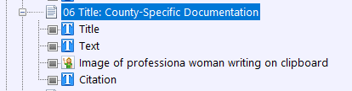
- For example, you do not want multiple items labeled with the same title on the same slide. (See Curriculum ADA Implementation 7/7/2020 for information on labeling images).
Screen readers do not differentiate between a bold header and body text. We have to indicate in the Title Explorer that an item is a slide title; we do so by including “Title”. 06 Title: County-Specific Documentation.
Label text boxes simply as Text, unless it is something special like a pro tip or quotation, or example. Label Citations simply as Citation.

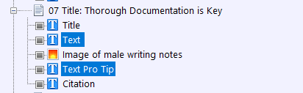

Transitions
Ensure there are transitions between slides when topics change and between all sections. These may be light recaps of progress and an introduction to what is next.

